** EXPERIMENT NUMBER 1.1 (Hall Effect)**

**Student Name: Shinde Smita Shahaji UID: 20BCS4643**

**Branch: CSE (IOT) Section/Group: IOT (Group-B)**

**Semester: 2nd semester Date of Performance:18/02/2021**

**Subject Name: Quantum and Semiconductor physics lab**

Subject Code: 20SPP-182

Hall Effect

AIM OF THE EXPERIMENT –

To determine the Hall Voltage and Hall Coefficient using Hall Effect.

APPARATUS- List of Equipment’s

|  |  |  |  |
| --- | --- | --- | --- |
| sr.no. | Equipment | Range | Quantity |
| 1. | Constant current power supply | 4A & 50V | 1 |
| 2. | Hall probe | NA | 1 |
| 3. | Digital gauss meter | 2-20k gauss | 1 |
| 4. | n-type germanium crystal | 0.7eV | 1 |
| 5. | Electromagnet | NA | 1 |
| 6. | Power supply for crystal | 0-8mA & 0-200mV | 1 |

OBSERVATIONS-

Table 1st – for magnetic field Vs current

|  |  |  |
| --- | --- | --- |
| Sr.no | Current I  (A) | Magnetic field H,  (Tesla) |
| 1. | 1 A | 0.1482 x 10^-4 |
| 2. | 1.5 A | 0.2223 x 10^-4 |
| 3. | 2 A | 0.2964 x 10^-4 |
| 4. | 2.5A | 0.3706 x 10^-4 |
| 5. | 3 A | 0.4447 x 10^-4 |

Material - Germanium

Table 2nd – For Halt Effect

|  |  |  |  |  |  |
| --- | --- | --- | --- | --- | --- |
| sr.no | magnetic field (tesla) | thickness  (in meter) | hall current (mili ampere) | halt voltage  (milli volt) | rh= VH*t/I*B |
| 1. | 0.4447 x 10^-4 | 0.2 x 10^-3 | 1 mA | 43.133 mV | 193.98 |
| 2. | 0.4447 x 10^-4 | 0.2 x 10^-3 | 1.5mA | 64.700 mV | 193.98 |
| 3. | 0.4447 x 10^-4 | 0.2 x 10^-3 | 2 mA | 86.267 mV | 193.98 |
| 4. | 0.4447 x 10^-4 | 0.2 x 10^-3 | 2.5 mA | 107.837 mV | 193.98 |
| 5. | 0.4447 x 10^-4 | 0.2 x 10^-3 | 3 mA | 129.400 mV | 193.98 |

CALCULATIONS-

-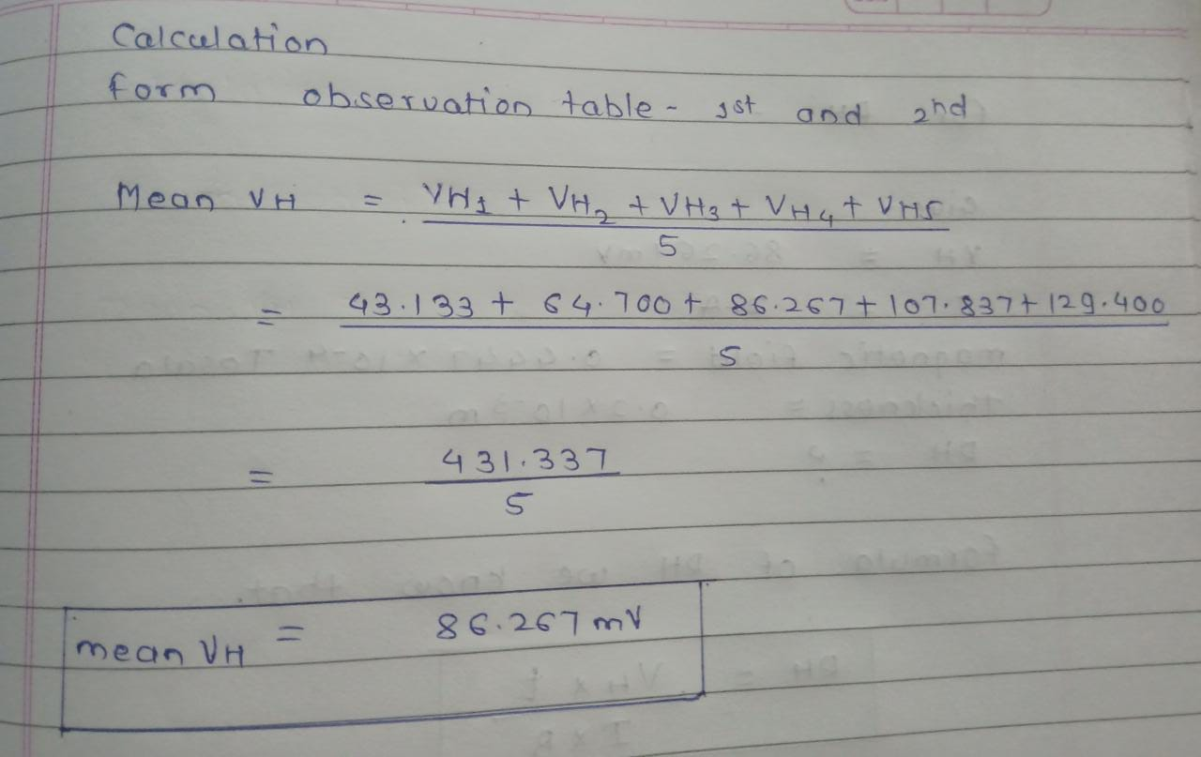

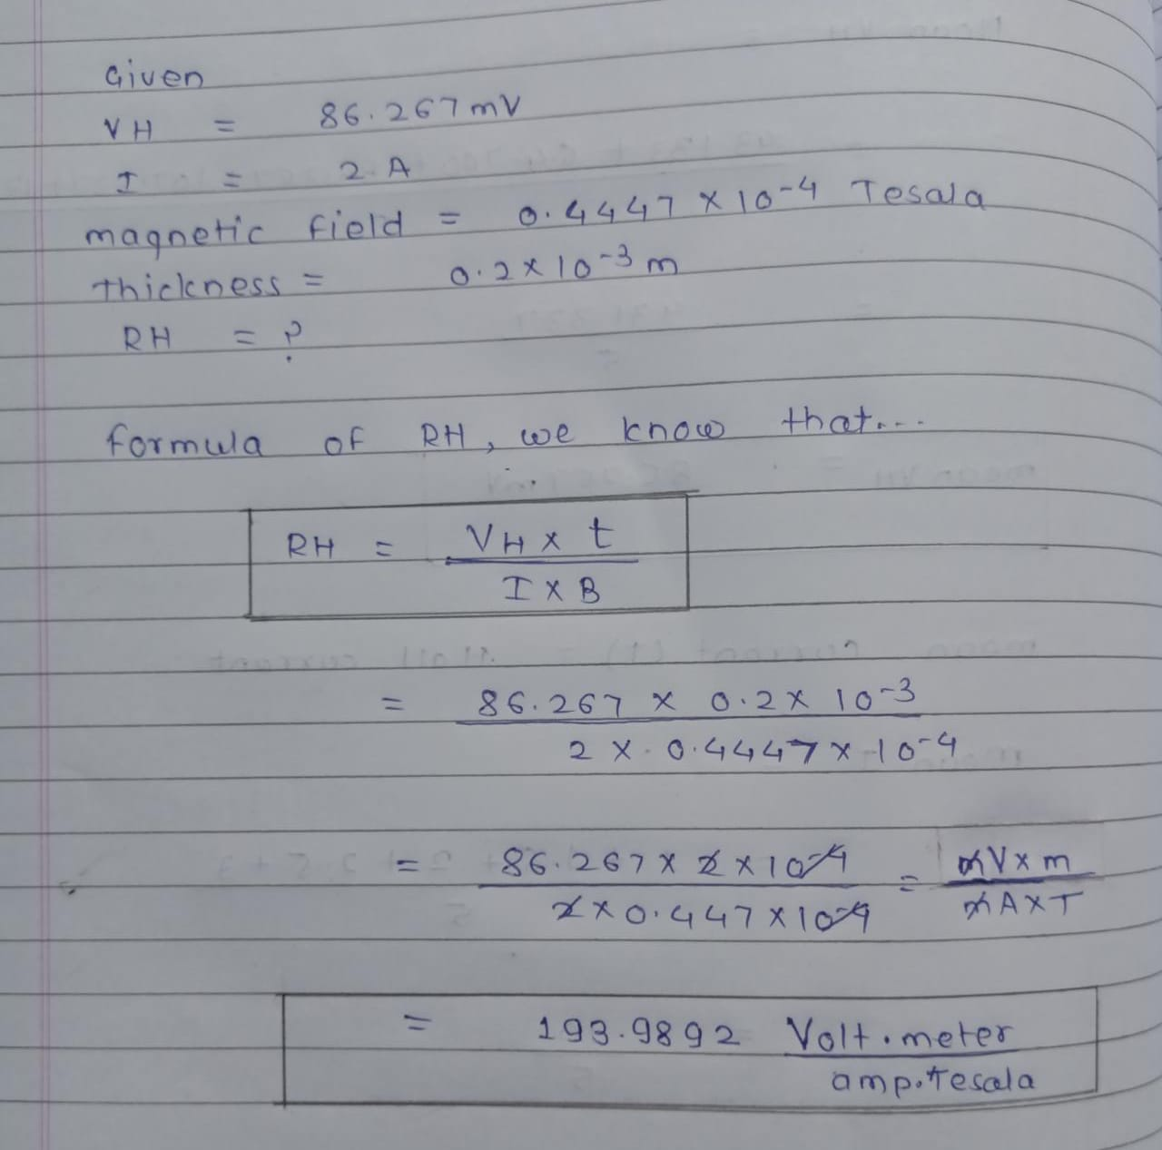

PERCENTAGE ERROR-

NIL – In this experiment we didn’t calculate any percentage so no error in percentage error.

GRAPH (ATTACH IF ANY)-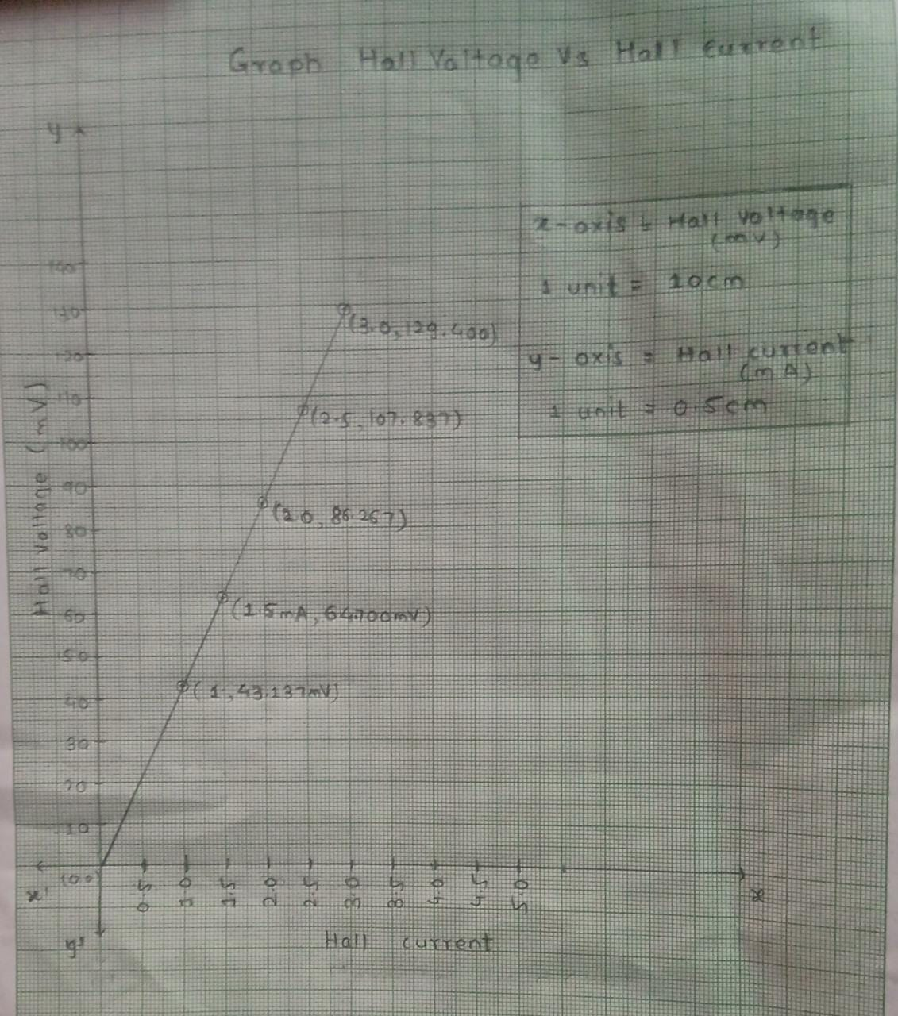

SOURCES OF ERROR-

1. Current should be remain constant reversed for each observation.
2. When probe not insert properly then no result is showing. Neither deflections of current meter
3. If current carrying conductor has not placed in a perpendicular magnetic field, a potential difference will not generate in the conductor which is perpendicular to both magnetic field and current.

RESULTS AND DISCUSSION-

The observed Hall voltage VH = 86.267mV

The Hall coefficient of material RH = 193.98volt m/ amp tesla

|  |
| --- |
| Result |

|  |
| --- |
| The Hall voltage across the material = 86.267 mV  The Hall coefficient of the material RH = 193.98volt m/ amp Tesla |

DISCUSSION-

During the experiment we took the precautions as given as below..

1. There should be no magnet, magnetic substance and current carrying conductor near the apparatus
2. The plane of the coil should be set in the magnetic meridian.
3. Current should remain constant and should be reversed for each observation

CONCLUSTION:

The Hall effect was verified as long as the current stayed below some threshold, there was a liner relationship between the voltage measured, and the current and B field applied

If a current carrying conductor placed in a perpendicular magnetic field, a potential difference will generate in the conductor which is perpendicular to both magnetic field and current. this phenomenon is known as HALL EFFECT.

LEARNING OUTCOMES

|  |
| --- |
| * It will provide the modest experience that allows students to develop and improve their experimental skills and develop ability to analyze data. |
| * Ability to demonstrate the practical skill on measurements and instrumentation techniques of some Physics experiments. Students will develop the ability to use appropriate physical concepts to obtain quantitative solutions to problems in physics. |
| * Students will demonstrate basic experimental skills by setting up laboratory equipment safely and efficiently, plan and carry out experimental procedures, and report verbally and in written language the results of the experiment. |
| * Students will develop skills by the practice of setting up and conducting an experiment with due regards to minimizing   measurement error. |

EVALUATION COLUMN (To be filled by concerned faculty only)

|  |  |  |  |
| --- | --- | --- | --- |
| **Sr. No.** | **Parameters** | **Maximum Marks** | **Marks Obtained** |
| 1. | Worksheet completion including writing learning objectives/Outcomes. (To be submitted at the end of the day) | 10 |  |
| 2. | Post Lab Quiz Result. | 5 |  |
| 3. | Student Engagement in Simulation/Demonstration/Performance and Controls/Pre-Lab Questions. | 5 |  |
| 4. | Total Marks | 20 |  |
| 5. | Teacher’s Signature (with date) |  | |